Exploring ROS 2.0

An investigation of the capabilities of the current release of ROS2 is carried out. Focus is maintained on the networking capabilities of the DDS middleware system and possible participants in the shared DDS data space. In particular, a ROS2 package known as microXRCE-DDS is used to allow eXtremely Resource Constrained Environment devices to communicate with other devices through the DDS publisher/subscriber model. This is demonstrated with an Arduino implementation. A simple demo of the networking capabilities of ROS2 is shown.

An Arduino MEGA 2560 was programmed to obtain data from an ultrasonic sensor and send this data, via the DDS middleware to a ROS2 system. This range data was then used to control the trajectory of a MARA M-Cobot simulation. To achieve this, a few different packages are used. The first is micro-XRCE-DDS this package provides a client-server system to allow the Arduino to participate in the DDS data space. Micro-XRCE-DDS provides an agent which performs operations such as participant, subscriber and publisher creation. In turn, the Arduino communicates with the agent, informing it which entities to create in the DDS data space. For the Arduino code, an existing library called ros2arduino is used.
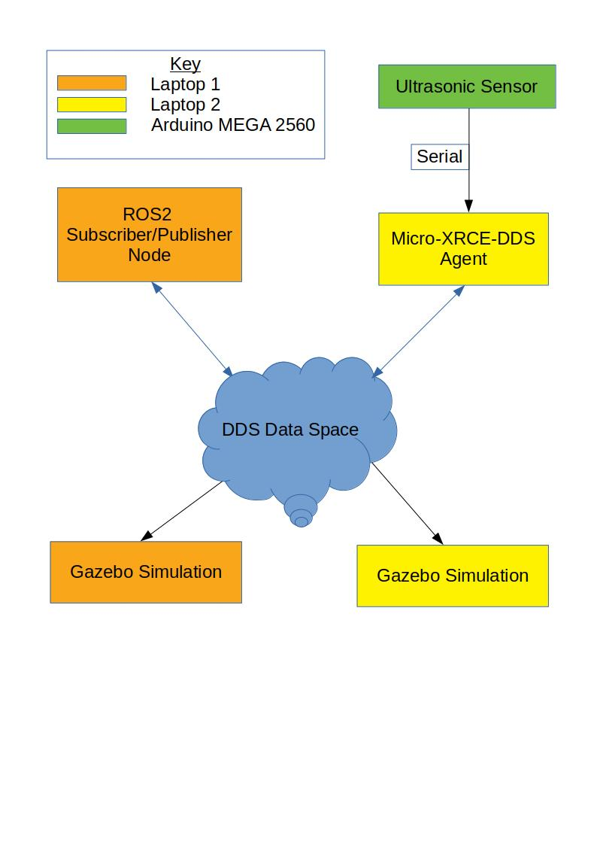
The diagram to the left shows the system architecture. The Arduino instructs the micro-XRCE-DDS agent to create and publish to the topic “/arduino_ranger”. The data from an ultrasonic sensor plugged into the Arduino is sent as a ROS2 message type “sensor_msgs/Range”. The ROS2 Subscriber/Publisher takes the range data and converts it to an angle for the simulated robot joint to achieve. This is then published to its own topic which is picked up by the gazebo simulation on both computers simultaneously. The simulated robot (MARA) is designed to operate in the ROS2 environment.

Code files are included with this document. RangePubTest.ino is the arduino code. Range.hpp is a header file required by ros2arduino since it doesn’t include the Range message type by default. If the code will not compile for the Arduino you are using, then the default size of the data packet can be reduced from 512 bytes to a lower value by altering the relevant header file. The lowest spec board that I was able to get it working on was an Arduino MEGA 2560 which has 256kb flash, 8kb ram and a 16Mhz 8-bit processor.

A big drawback of using such resource constrained hardware in the network is that any hardware that must be connected in this way requires the agent which becomes a single point of failure for any hardware connected to it. Multiple agents can be used in a single network however, controlling a number of devices each.

Some interesting work is being done by the makers of MARA, Acutronic Robotics, in designing modular robot configurations powered by ROS2. They are involved in the development of a specification to enable cross-manufacturer modular robotics, known as HRIM (Hardware Information Robot Model). These specifications are being developed in close collaboration with the ISO and OMG standardisation bodies.

